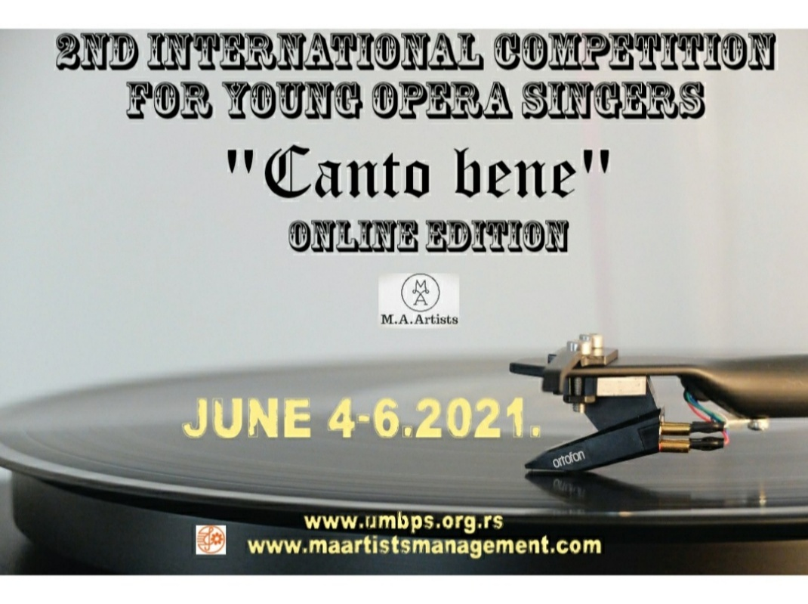

II MEDJUNARODNO ONLINE TAKMIČENJE MLADIH OPERSKIH PEVAČA “CANTO BENE”

(4-6.juna 2021.)
___________________________________________________________

Ime i prezime :

________________________________

Datum rodjenja:
________________________________

Ime i prezime klavirskog saradnika:
________________________________

Ima i prezime profesora
________________________________

Muzička škola/Akademija(završen Fakultet)

________________________________

E-mail takmičara:

________________________________

Program:

_________________________________

_________________________________

_________________________________

Linkovi pesama/arija:

________________________________

________________________________

Kratak CV takmičara:

__________________________________________________________________________________________________________________________________________________________________________________________________________________________________________________________________________________________________________________________________________________________________________________________________________________________________________________________________

Fotografija takmičara u JPEG formatu:

telefon/faks: (011) 319-3582 mejl:umbps@hotmail.com sajt: www.umbps.org.rs
cantobene@yandex.ru

