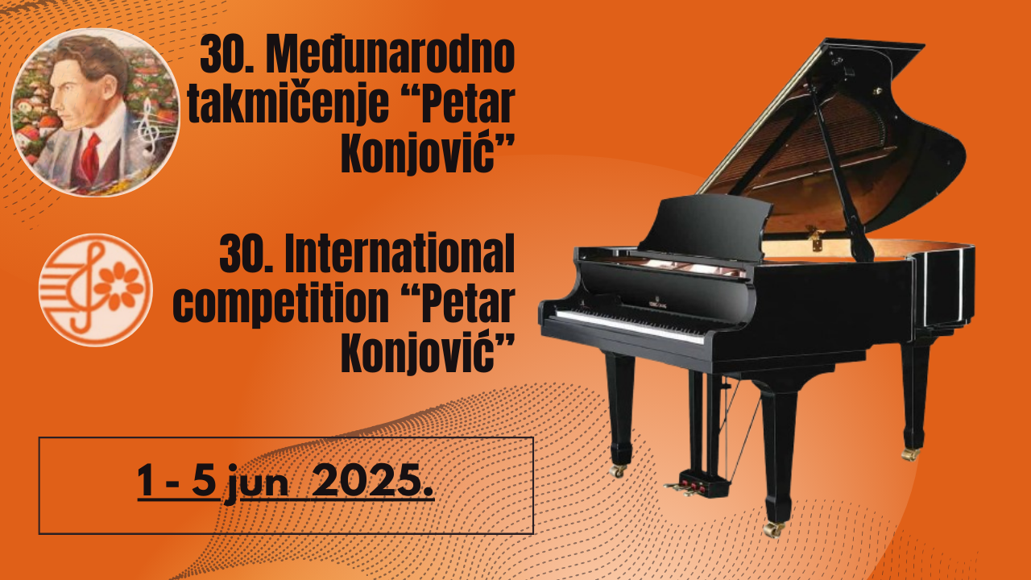

**Name of the competition**:

**30th INTERNATIONAL COMPETITION OF YOUNG MUSICIANS**

**„PETAR KONJOVIĆ“**

(me international ranking competition)

**Place and date of performance:**

Belgrade, June 2025. year

PROPOSITIONS

**PIANO**

**I CATEGORY**   
Born on 2016 or younger  
Competition program lasting-up to 8 minutes  
**Program**

1. Etude of candidate’s choice   
2. The composition of free choice

**II CATEGORY**   
Born on 2014. or younger  
Competition program lasting-up to 10 minutes

**Program**  
1.One movement of a sonata in sonata form

2.Virtuose etude

3. The composition of free choice from romanticism to today

**III CATEGORY**  
Born on 2012. or younger  
Competition program lasting - up to 15 minutes  
**Program**  
1. One movement of a sonata in sonata form

2. Virtuoso Etudes  
3. The composition of free choice from romanticism to today

**IV CATEGORY**  
Born on 2010. or younger  
Competition program lasting - up to 20 minutes  
**Program**  
1. One movement of a sonata in sonata form

2. Virtuoso Etude

3. The composition of free choice-from romanticism to today

**V CATEGORY**  
Born 2009. or younger  
Competition program lasting - up to 25 minutes  
**Program**  
1. One movement of a sonata in sonata form

2. Virtuoso Etude

3. The composition of free choice-from romanticism to today

**VI CATEGORY**  
Born 2007. or younger  
Competition Program lasting- up to 30 minutes  
**Program**

1. One movement of a sonata in sonata form

2. Virtuoso Etude

3. The composition of free choice-from romanticism to today

**VII CATEGORY**  
Born 1999 . or younger  
Competition Program lasting-up to 40 minutes  
**Program**  
Free choice program composed of compositions from at least 2 different eras