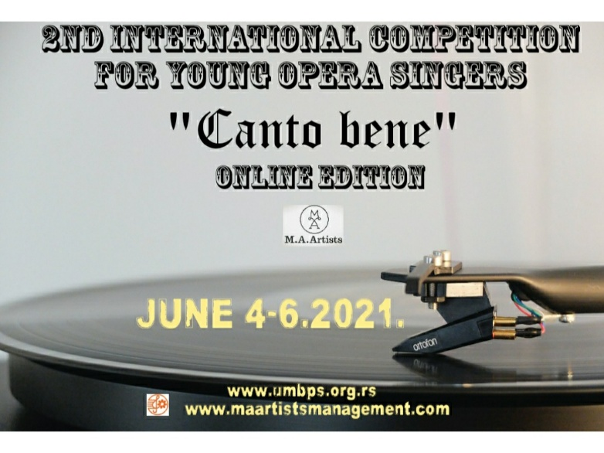

2nd INTERNATIONAL COMPETITION ONLINE “CANTO BENE” FOR YOUNG OPERA SINGERS

(June 4-6.2021.)

__________________________________________________________________________

Name and Surname

________________________________

Date of Birth
________________________________

Name ans Surname of Pianist
________________________________

Name and Surname of Prof./vocal coach

________________________________

Music school/Academy (or finished Academy)

E-mail of competitor :

________________________________

Program:

_________________________________

_________________________________

_________________________________

Links for songs/arias:

________________________________

________________________________

Short CV of the competitior:

__________________________________________________________________________________________________________________________________________________________________________________________________________________________________________________________________________________________________________________________________________________________________________________________________________________________________________________________________

Picture in JPEG format:

telefon/faks: (011) 319-3582 mejl: umbps@hotmail.comsajt: www.umbps.org.rs
cantobene@yandex.ru

