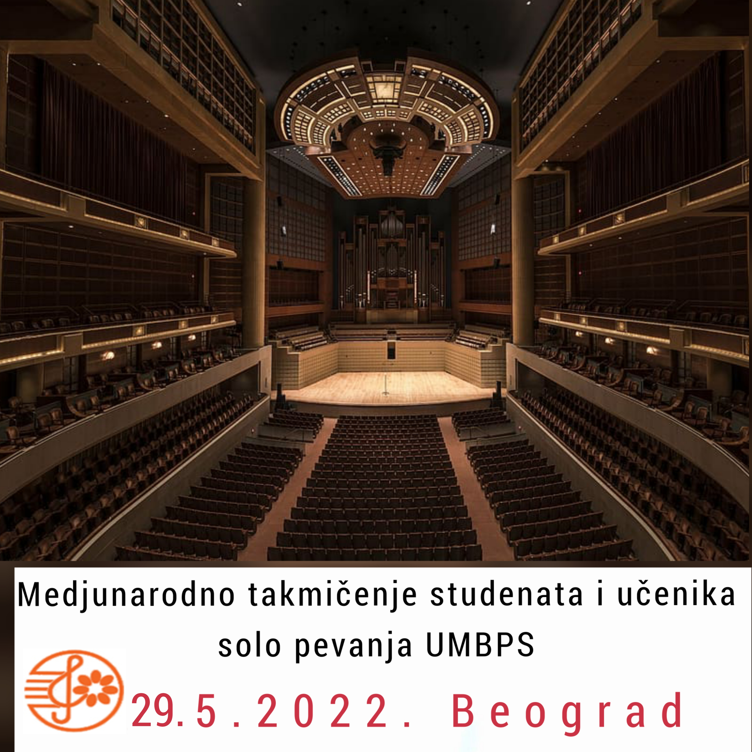
INTERNATIONAL COMPETITION FOR YOUNG OPERA SINGERS UMBPS

BELGRADE 28.5.2022
APPLICATION FORM

DEADLINE 20/05/2022 AFTER THE DATE NOT RECEIVE APPLICATIONS
NAME AND SURNAME
CONTACT ADDRESS (street, number, city, country) |  |  |  |  |  |  |  |  |  |  |  | date and place of birth |  | Class OMS, SMS
EMAIL |  |  |  |  |  |  |  |  |  |  |  | PHONE
PIANO ASSISTENT |  |  |  |  |  |  |  |  |  |  | I NEED SERVICES OF OFFICIAL PIANO ASSISTENT |  |  | YES NO
CATEGORY |  |  |  |  |  |  |  |  | INSTRUMENT:
MUSIC INSTITUTION OF THE APPLICANT (NAME, ADDRESS, PHONE, FAX, EMAIL)
Program: (COMPOSER, ORIGINAL TITLE, TONALITY, OPUS, NUMBER, MOVEMENT AND DURATION – SEPARATELY FOR EACH STAGE):

Klasa –profesor (professor)
Telefon, mejl (telephone, email)
To submit their verified receipt of payment of the registration fee.
Applications should be sent. UMBPS to the address or e-mail, umbps@mts.rs or by mail to the address of the Association of Music and Ballet pedagogues Serbia
John Kennedy 7, Belgrade.
Applications sent by mail may not be signed.
Application forms have to be sent to the following email: umbps@mts.rs until 20/05/2022.
The candidates from the foreign countries pay the donation in EUR to the following account:
Beneficiary:
IBAN: RS35160005080002629395
Beneficiary name: UDRUZENJE MUZICKIH I BALETSKIH PEDAGOGA
Beneficiary address: Dzona Kenedija street, No 7, 11080 Zemun, Serbia
Bank name: BANCA INTESA AD, BEOGRAD
Bank address: MILENTIJA POPOVICA 7B, BEOGRAD, REPUBLIKA SRBIJA
Bank swift code: DBDBRSBG
For elementary school students fee is 2500 rsd
For high school students and Academy students 3000 rsd
Transfer to be made via an intermediary bank (you can put these under 'special instructions')
Bank Name: INTESA SANPAOLO SPA, MILANO, ITALY
SWIFT code: BCITITMM

