International competition “Slavic music festival Belgrade 2021”
-online editon-
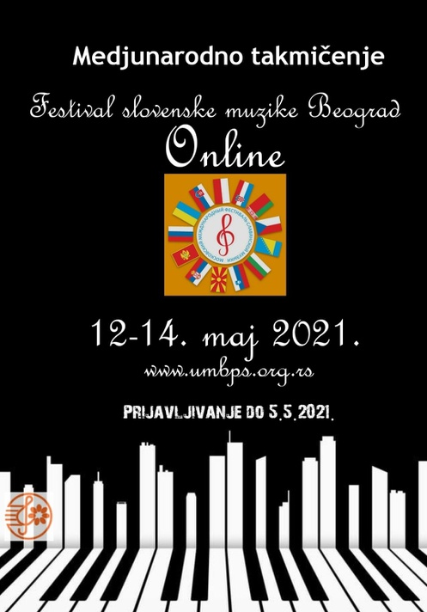
Organisation:
Association of Music and Ballet pedagogues of Serbia
www.umbps.com
www.umbps.org.rs
Director of competition Prof. Vojislav Avramović
Partners:
Art school “M.A.Balakirev” Moscow
www.balakirevschool.ru
M.A.Artists Management , Belgrade
www.maartistsmanagement.com
Russian house for science and culture, Belgrade
www.ruskidom.rs
Jury members:
Piano category
Elena Kuznetsova, President of the Jury
(Russian Federation)
Ilya Chudnetsov
(Russian Federation)
Veronika Korina
(Russian Federation)
Vojislav Avramović
(Republic of Serbia)
Margarita Vujović
(Letonia/Serbia)
Jury for opera singing:
Lyudmila Safonova,President of the Jury
(Russian Federation)
Araik Avanyan
(Armenia/France)
Anastasija Holc
(Republic of Serbia)
Jury for violin and cello:
Yevgeny Xaviereff, Presdient of the jury
(Belarus/ Georgia )
Orest Shourgot
(Ukraine)
Vladimir Marković
(Republic of Serbia)

Jury for accordion:
Danijela Rakić, President of the jury
(Republic of Serbia)
Miodrag Krstić
(Republic of Serbia)
Miloš Lončar
(Republic of Serbia)

Competitors:
Piano section
Ivan Chernukhin ( II category )
Russia/Serbia
Beihong Lin (III category )
China
Leontina Nikolić (III category)
Serbia
Eleni Hadjiosif (III category)

Antonia Tasu (III category)
Romania
Katarina Tomić( III category)
Serbia
Blandu Ruxandra ( III category)
Romania
Tara Vukadiović (III category)
Serbia
Marija Šapovalova (III category)
Russia/Serbia
Andrej Djordjević (IV category)
Serbia
Marija Jovanović( IV category)
Serbia
Stefan Lopandić (V category)
Bosnia and Herzegovina
Darja Samofalova (VII category)
Russia

Opera singing
Mihajlo Dražić Cep ( I category)
Serbia
Marko Đanić ( I category)
Serbia
Mina Lečić ( I category )
Serbia
Sara Buček (II category)
Serbia
Teodora Zbilić (II category)
Serbia
Darinka Milenković (II category)
Serbia
Tamaš Kiš (IV category)
Serbia/Hungary
Jovana Kovačević (IV category)
Serbia
Tamara Milovanović (V category)
Serbia
Bojan Pavlović (V category)
Serbia
Aleksandar Simić (V category)
Serbia
Nina Lazendić (VI category)
Serbia
Nina Zubac (VI)
Serbia

Violin and cello category
Petra Babić (Cello I)
Serbia
Kalina Filipović (Cello I)
Serbia
Hana Pavić (Cello I)
Serbia
Djordje Miladinović (Violin II )
Serbia
Petra Miljković (Cello II )
Serbia
Relja Mitrović (Cello III )
Serbia
Jasmina Filić (Cello II )
Serbia
Lana Zorjan
(Violin II)
Serbia
Vuk Stevanović (Violin II )
Serbia
Marija Badnjar (Violin III )
Serbia
Emilija Krunić (Cello III )
Serbia
Tijana Pavlović (Cello III )
Serbia
Anja Radjenović ( Cello III )
Serbia
Andrej Balaž (Violin IV )
Serbia
Veronika Mona Bogić
(Violin V )
Serbia
Accordion category
Lazar Jončić (III category)
Serbia
Vlajko Jovanović (III category)
Serbia
Dimitrije Petrović (III category)
Serbia
Ivor Javor Korjenić (VI category)
Croatia
Concert of the best competitiors for the year 2020 and 2021 „Slavic music festival Belgrade“ will be held at Russian house for science and culture, Belgrade on 2nd of june 2021 at 5 o’clock p.m.
