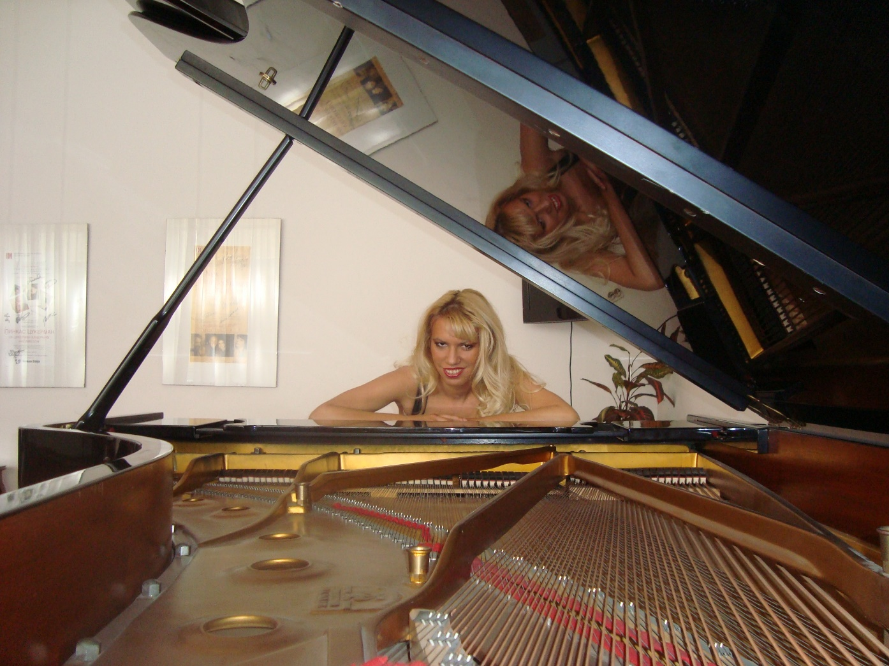

Dina Hadziomerovic

Dina Hadziomerovic (1981) is a Serbian pianist, enrolled the Faculty of Music in Belgrade at the age of sixteen. She graduated with Honors in piano at the class of prof. Ninoslav Zivkovic in 2003. After that, she enrolled Master Degree Studies at the class of prof. Nevena Popovic (while studying, she was engaged at the Faculty of Music as demonstrator at the piano department) and graduated in 2010 (Mentor prof. Ninoslav Zivkovic). Currently she is on her final year of PhD studies at Faculty of Music in Belgrade (Mentor prof.Maja Rajkovic).

During studies, she has won several first, second and special prizes on many competitions in Serbia and international competitions abroad (“Nikolai Rubinstein” - Paris, “Concorso Internazionale di Musica Citta di Stresa” - Italy, “International Chopin competition” - Czech Republic, “Dr Vojislav Vuckovic”, EPTA, “Davorin Jenko”, “Vasilije Mokranjac” and others).

She has performed as a soloist in all prestigious concert venues. She has also presented numerous recitals in the cities all around Serbia, performed abroad (Montenegro, Czech Republic, France, Italy, Croatia) and attended various domestic and international courses held by eminent professors (Vladimir Ovchinikov, Paul Gulda, Aleksandar Madzar, Ruben Dalibaltayan and others).

She also achieved notable results in chamber music with the violinist Nemanja Marjanović, and the violinist Marija Misita, with whom she performed at several concerts, and in the piano duo with Sara Vujadinović she performed for several years. Together, they performed numerous concerts and they represented Serbia at the "World piano conference" in Novi Sad.

From 2002 she is engaged in “Kosta Manojlovic” Music School in Zemun. Starting 2014, she is engaged in pedagogical work. Within just six years of pedagogical engagement, even 10 students graduated from her class, 7 of whom enrolled at the Faculty of Music in Belgrade, the Academy of Arts in Novi Sad, the Royal Conservatory of Music "Glen Gould" in Toronto, and the Royal College of Music in London.

Dina raised a new generation of young pianists who achieved tremendous results and became prize winners of various international competitions (over 100 awards). Every year, her students perform at all major concerts in all prestigious concert venues (KNU, Philharmonic, Sanu Gallery, Artget Gallery, etc.)

She has been awarded several times for her pedagogical work and also, she was a jury member in some competitions. At the International Competition in Smederevo, which was attended by many candidates from 20 countries, she was one of 4 professors who won a special award for extraordinary pedagogical results.

In 2019, Dina worked on a special project that was premiere performed in Serbia. She arranged a composition written for 8 hands to the composition for 16 hands, on two pianos, which she performed together with the students (https://youtu.be/OhVE57nWK6w)

