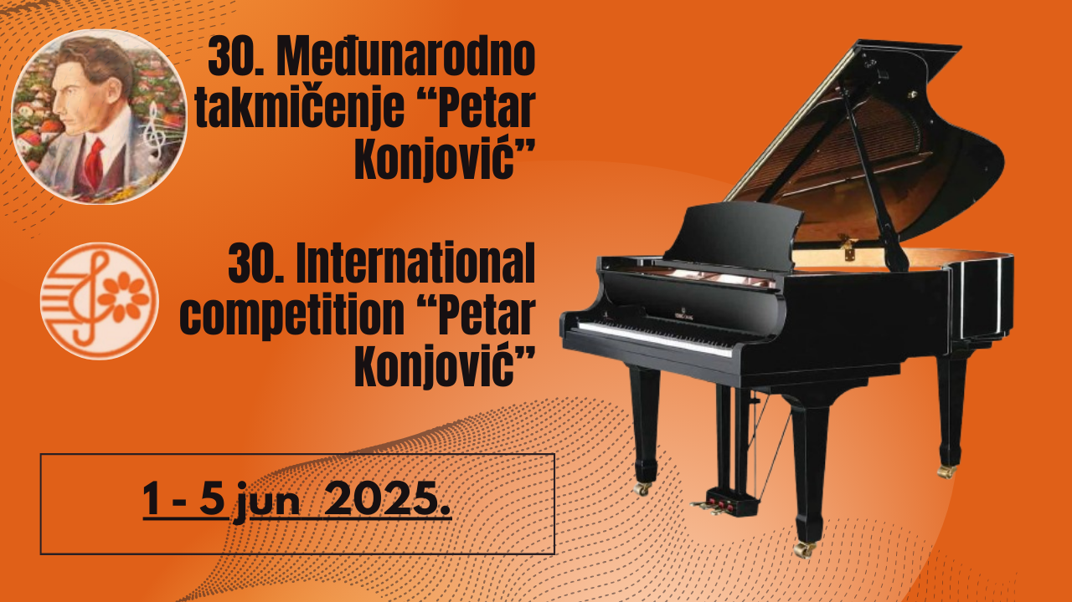

**Name of the competition**:

**30th INTERNATIONAL COMPETITION OF YOUNG MUSICIANS**

**„PETAR KONJOVIĆ“**

(me international ranking competition)

**Place and date of performance:**

Belgrade, June 2025. year

PROPOSITIONS

**SOLO SINGING**

**JUNIOR CATEGORY:**

Girls born in 2006 and younger

Young men born in 2004 and younger

**Program**

1. Aria antthe of your choice
2. Solo song of your choice

**I CATEGORY:**

Girls born in 2004 and younger

Young men born in 2002 and younger

**Program**

1. Aria antthe of your choice
2. Solo song of your choice (German, French or Russian composer)
3. Solo song by Petar Konjović

**II CATEGORY:**

Girls born in 2002 and younger

Young men born in 2000 and younger

**Program**

1. Aria antthe of your choice
2. Solo song of your choice (German, French or Russian composer)
3. Solo song by Petar Konjović
4. Aria from an opera or operetta

**III CATEGORY:**

Girls born in 2000 and younger

Young men born in 1998 and younger

**Program**

1. Aria antthe of your choice
2. Solo song of your choice (German, French or Russian composer)
3. Solo song by Petar Konjović
4. A solo song by a composer from the country the candidate represents
5. An aria from an opera or an operetta of your choice

**IV CATEGORY:**

Girls born in 1998 and younger

Young men born in 1996 and younger

**Program**

**FIRST STAGE**

1. Aria antthe of your choice
2. Aria from an oratorio, cantata or mass
3. Opera or concert aria by VA Mozart

**SECOND STAGE**

1. A solo song by a 19th century composer of your choice
2. A solo song by a 20th century composer of your choice
3. Solo a song by Petar Konjović
4. An aria from an opera or an operetta of your choice

**V CATEGORY:**

Girls born in 1995 and younger

Young men born in 1993 and younger

**Program**

**FIRST STAGE**

1. Aria antthe of your choice
2. Aria from an oratorio, cantata or mass
3. Opera or concert aria by VA Mozart
4. Solo song by a 19th century composer of free choice (Lied)

**SECOND STAGE**

1. A solo song by a 20th century composer of your choice
2. Solo song by Petar Konjović
3. An aria from an opera or an operetta of your choice
4. A solo song by a composer from the country the candidate represents

*\*Within each category, awards are given separately for female and separately for male voices.*