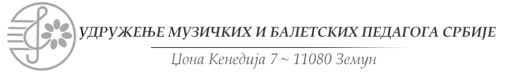
telefon/faks: (011)719-3582 mejl:umbps@mts.rs sajt: www.umbps.com

SLAVIC MUSIC FESTIVAL 3- 6 April 2023.
APPLICATION FORM

NAME AND SURNAME
CONTACT ADDRESS (street, number, city, country) |  |  |  |  |  |  |  |  |  |  |  | date and place of birth |  | Class
EMAIL
PIANO ASSISTENT
CATEGORY |  |  |  |  |  |  |  |  | INSTRUMENT:
MUSIC INSTITUTION OF THE APPLICANT (NAME, ADDRESS, PHONE, FAX, EMAIL)
Program: (COMPOSER, ORIGINAL TITLE, TONALITY, OPUS, NUMBER, MOVEMENT AND DURATION – SEPARATELY FOR EACH STAGE):

Professor
Phone
To submit their verified receipt of payment of the registration fee.
Applications should be sent to the address by e-mail to umbps.rs@gmail.com
John Kennedy 7, Belgrade.
Applications sent by mail may not be signed.
Application forms have to be sent to the following email: umbps.rs@gmail.com until 20.03.2022.
The candidates from the foreign countries pay the donation in EUR to the following account:
Beneficiary:
IBAN: RS35160005080002629395
Beneficiary name: UDRUZENJE MUZICKIH I BALETSKIH PEDAGOGA
Beneficiary address: Dzona Kenedija street, No 7, 11080 Zemun, Serbia
Bank name: BANCA INTESA AD, BEOGRAD
Bank address: MILENTIJA POPOVICA 7B, BEOGRAD, REPUBLIKA SRBIJA
Bank swift code: DBDBRSBG
Transfer to be made via an intermediary bank (you can put these under 'special instructions')
Bank Name: INTESA SANPAOLO SPA, MILANO, ITALY
SWIFT code: BCITITMM
With the indication: Participation in the competition “The festival of Slavic music 2023."
PARTICIPATION FEE FOR ONLINE COMPETITIORS IS 30 EUROS

